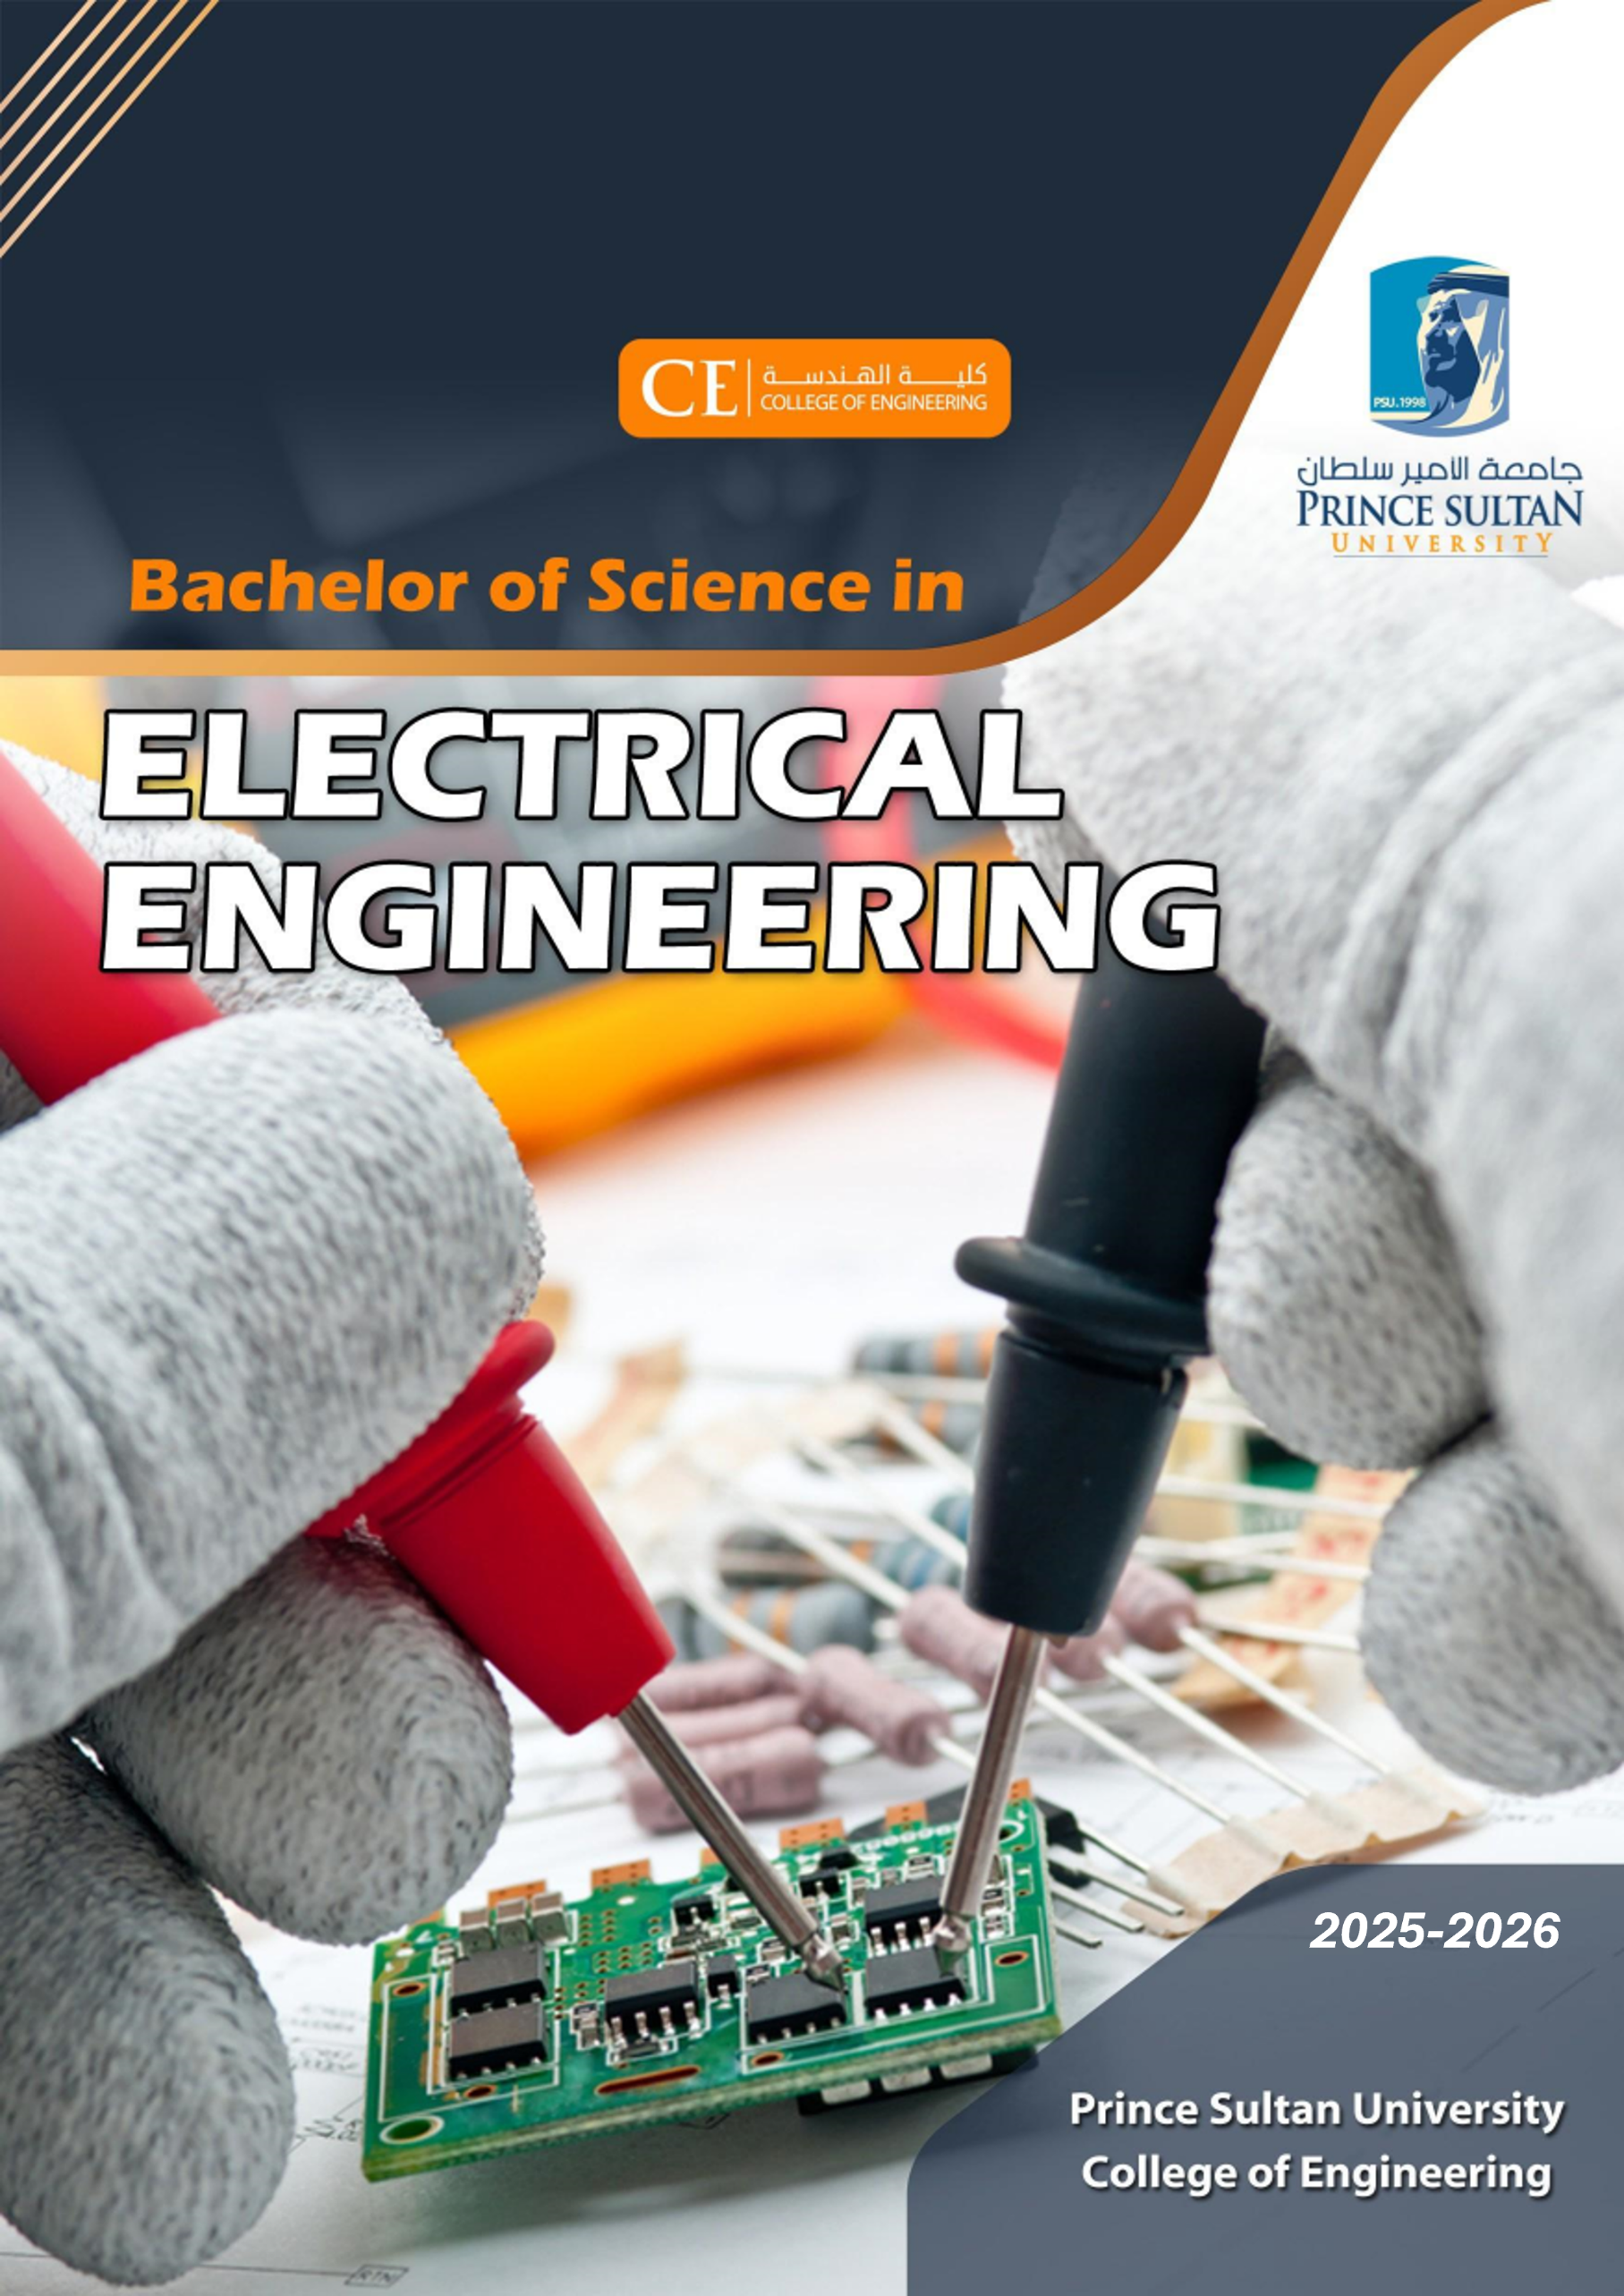

INTRODUCTION
The Electrical Engineering (EE) Program aims to respond to the high demand in the Middle East for engineers who can develop innovative approaches to solving engineering problems. Investigations and surveys of human resources needs in Saudi Arabia have indicated a high demand for highly qualified electrical engineers. The economy is growing, especially in the field area of electrical engineering, where significant investments are being made.
The EE Program aligns with Saudi Vision 2030 by training and educating students to develop the electrical power infrastructure, especially in transmission and distribution networks, and the renewable energy market. The program teaches the fundamentals of these aspects along with the specific needs of the market.
The EE Program is conceived with industry partners, ensures world-class facilities, and provides knowledge and technical expertise in the latest research areas like Smart Grid, Power Electronics, Electric Vehicles, etc. Electrical engineers are required in various core industries, including IT companies in the private and public sectors. Additionally, the program enhances the creativity of students to develop innovative projects and eventually results in novel products for the market and society's needs.
A Bachelor of Science (BS) in Electrical Engineering is awarded upon successful completion of 138 credit hours. This includes 3 credits of capstone project, 6 credits of technical electives, and 10 credits of field experience.

PROGRAM EDUCATIONAL OBJECTIVES
Graduates of the Bachelor of Science in Electrical Engineering are expected, within a few years of graduation, to have demonstrated:
- EE graduates will apply electrical engineering knowledge and skills to design solutions, solve complex problems, and pursue graduate studies and research, demonstrating creativity and innovation.
- EE graduates will uphold ethical standards, commit to sustainability, and pursue lifelong learning.
- EE graduates will demonstrate leadership, critical thinking, decision-making, and teamwork, contributing positively to their organizations and society.

CAREER OPPORTUNITIES
- Power Systems Engineer: Design, operate, and maintain electrical grids supporting cities and industries.
- Renewable Energy Engineer: Develop and integrate solar, wind, and energy-storage technologies.
- Control Systems Engineer: Automate industrial processes in manufacturing, oil & gas, and transportation.
- Electrical Design Engineer: Create electrical systems for buildings, plants, and industrial facilities.
- Power Electronics Engineer: Build inverters, converters, and EV charging systems.
- Telecommunications Engineer: Support digital communication networks and smart technologies.
- Project Manager: Lead engineering teams and deliver large-scale technical projects.

PROGRAM STRUCTURE

Course Type | Credit Hours
UNIVERSITY REQUIREMENTS | 23
COLLEGE REQUIREMENTS | 51
CAPSTONE PROJECT | 3
PROGRAM CORE REQUIREMENTS | 45
PROGRAM ELECTIVE REQUIREMENTS | 6
FIELD EXPERIENCE | 10
Total | 138

UNIVERSITY REQUIREMENTS (23 Credits):
Course Code | Course Title | Credit Hrs. | Prerequisite
ENG 101 | Intensive Writing | 3 | -
ISC 101 | Islamic Ethics | 2 | -
COM 201 | Communication Skills | 3 | -
ISC 103 | Islamic Economic System | 2 | -
ARAB 101 | Arabic Writing I | 2 | -
ISC 105 | Studies of The Holy Quran | 2 | -
ISC 203 | Contemporary Financial Transactions | 2 | -
ARAB 103 | Arabic Writing II | 2 | -
ARAB 203 | Arabic Writing III | 2 | -
PSY 101 | Introduction to Psychology | 3 | -
Total |  | 23

COLLEGE REQUIREMENTS (51 Credits):

Course Code | Course Title | Credit Hrs. | Prerequisite
MATH 111 | Calculus I | 3 | -
MATH 113 | Calculus II | 3 | MATH 111
MATH 215 | Engineering Mathematics | 3 | MATH 113
MATH 225 | Differential Equations | 3 | MATH 113
MATH 223 | Linear Algebra | 3 | MATH 113
PHY 105 | Physics I | 4 | -
PHY 205 | Physics II | 4 | PHY 105
CHM 101 | General Chemistry | 4 | -
STAT 101 | Introduction to Statistics and Probability Theory | 3 | MATH 111
ENG 301 | Technical Writing and Translation | 3 | ENG 101
ETHC 305 | Ethical and Social Aspects of Engineering | 2 | -
EM 326 | Project Management | 3 | STAT 101
EM 327 | Engineering Economy | 3 | MATH 113
CEE 101 | Engineering Drawing | 3 | -
CEE 205 | Introduction to Engineering Design | 3 | CEE 101
EE 101 | Computer Programming for Engineering | 4 | -
Total |  | 51

CAPSTONE PROJECT (3 Credits):
Course Code | Course Title | Credit Hrs. | Prerequisite | Corequisite
EE 490 | Senior Design Project | 3 | CEE 205, ENG 301, Completion of 90 credit hours | ETHC 305
Total |  | 3

PROGRAM REQUIREMENTS (61 Credits):
- Core Courses (45 Credits):
Course Code | Course Title | Credit Hrs. | Prerequisite
EE 201 | Introduction to Circuits | 4 | PHY 205, MATH 113
EE 211 | Electronic Fundamentals | 4 | EE 201
EE 221 | Logic Design | 4 | EE 101
EE 231 | Signals and Systems | 3 | MATH 225, EE 201
EE 202 | Circuit Analysis | 3 | MATH 225, EE 201
EE 312 | Electronic Engineering | 3 | EE 211
EE 322 | Microprocessors Design | 4 | EE 211, EE 221, CEE 205
EE 341 | Electromagnetics Fundamental | 3 | MATH 215, MATH 225, EE 201
EE 332 | Control Systems | 3 | MATH 223, EE 231
EE 351 | Communication Systems | 4 | EE 211, EE 231
EE 305 | Power Electronics | 4 | EE 211
EE 304 | Electrical Machines | 3 | EE 202, EE 341
EE 403 | Power Systems | 3 | EE 304
Total |  | 45

- Field Experience (10 Credits):
Course Code | Course Title | Credit Hrs. | Prerequisite
EE 492 | Cooperative Training | 10 | Completion of 128 credit hours
Total |  | 10

- Elective Courses (6 Credits):
Student should take two courses only from the following technical electives:

Course Code | Course Title | Credit Hrs. | Prerequisite
EE 414 | Electrical and Electronic Measurements | 3 | Completion of  90 credit hours
EE 415 | Opto-Electronics | 3
EE 416 | VLSI Circuits Design | 3
EE 417 | Communications Electronics | 3
EE 423 | Data Communication Networks | 3
EE 424 | Digital Communications | 3
EE 425 | Wireless Communications Systems | 3
EE 426 | Antenna and Wave Propagation | 3
EE 433 | Mechatronics | 3
EE 434 | PLC Microcontrollers | 3
EE 435 | Robotics and Automation | 3
EE 436 | Artificial Intelligence | 3
EE 442 | Digital Signal Processing | 3
EE 454 | Power System Planning | 3
EE 456 | Renewable Energy Engineering | 3
EE 499 | Special Topics in Electrical and Electronic Engineering | 3
Total |  | 6

PROGRAM STUDY PLAN
YEAR 1
First Semester |  |  | Second Semester
Code | Title | Hrs | Code | Title | Hrs
ENG 101 | Intensive Writing | 3 | ISC 101 | Islamic Ethics | 2
MATH 111 | Calculus I | 3 | COM 201 | Communication Skills | 3
PHY 105 | Physics I | 4 | MATH 113 | Calculus II | 3
CHM 101 | General Chemistry | 4 | PHY 205 | Physics II | 4
EE 101 | Computer Programming for Engineering | 4 | STAT 101 | Introduction to Statistics and Probability Theory | 3
 |  |  | CEE 101 | Engineering Drawing | 3
Total |  | 18 | Total |  | 18

YEAR 2
First Semester |  |  | Second Semester
Code | Title | Hrs | Code | Title | Hrs
ARAB 101 | Arabic Writing I | 2 | ARAB 103 | Arabic Writing II | 2
MATH 215 | Engineering Mathematics | 3 | MATH 223 | Linear Algebra | 3
MATH 225 | Differential Equations | 3 | EM 327 | Engineering Economy | 3
CEE 205 | Introduction to Engineering Design | 3 | EE 211 | Electronic Fundamentals | 4
EE 201 | Introduction to Circuits | 4 | EE 231 | Signals and Systems | 3
EE 221 | Logic Design | 4 | EE 202 | Circuit Analysis | 3
Total |  | 19 | Total |  | 18

YEAR 3
First Semester |  |  | Second Semester
Code | Title | Hrs | Code | Title | Hrs
ISC 103 | Islamic Economic System | 2 | ISC 105 | Studies of The Holy Quran | 2
ENG 301 | Technical Writing and Translation | 3 | ISC 203 | Contemporary Financial Transactions | 2
EE 312 | Electronic Engineering | 3 | ARAB 203 | Arabic Writing III | 2
EE 322 | Microprocessors Design | 4 | EM 326 | Project Management | 3
EE 341 | Electromagnetics Fundamental | 3 | EE 332 | Control Systems | 3
EE 351 | Communication Systems | 4 | EE 305 | Power Electronics | 4
 |  |  | EE 304 | Electrical Machines | 3
Total |  | 19 | Total |  | 19

YEAR 4
First Semester |  |  | Second Semester
Code | Title | Hrs | Code | Title | Hrs
PSY 101 | Introduction to Psychology | 3 | EE 492 | Cooperative Training | 10
ETHC 305 | Ethical and Social Aspects of Engineering | 2
EE 403 | Power Systems | 3
EE 4xx | Elective 1 | 3
EE 4xx | Elective 2 | 3
EE 490 | Senior Design Project | 3
Total |  | 17 | Total |  | 10

PROGRAM ACADEMIC PLAN

